Name _____________________________ |  |  | Date ___________________
Write Directions
Use the following map to write directions.
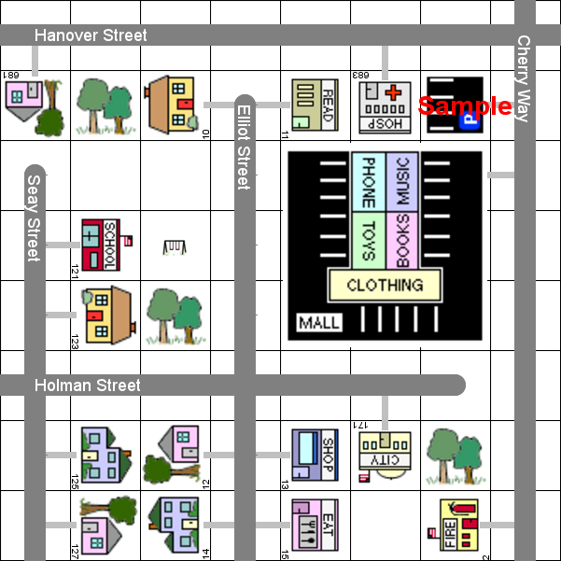
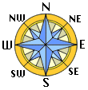

Name _____________________________ |  |  | Date ___________________
Write Directions

1. | Write directions to go from the library at 11 Elliot Street to the city hall at 171 Holman Street.

2. | Write directions to go from the house at 10 Elliot Street to the house at 127 Seay Street.

3. | Write directions to go from the fire station at 2 Cherry Way to the hospital at 683 Hanover Street.

4. | Write directions to go from the house at 14 Elliot Street to the school at 121 Seay Street.

5. | Write directions to go from the school at 121 Seay Street to the city hall at 171 Holman Street.

6. | Write directions to go from the store at 13 Elliot Street to the house at 125 Seay Street.

